AML FINAL PROJECT

1. Introduction

Deep learning is a machine-learning technique that teaches machines to do what is known or learned by humans naturally. The key technology behind many great inventions like Autonomous driving, and voice control in consumer devices uses tools such as Image recognition tools, natural language Processing (NLP), and speech recognition software, medical diagnosis, stock market trading signals, security network.

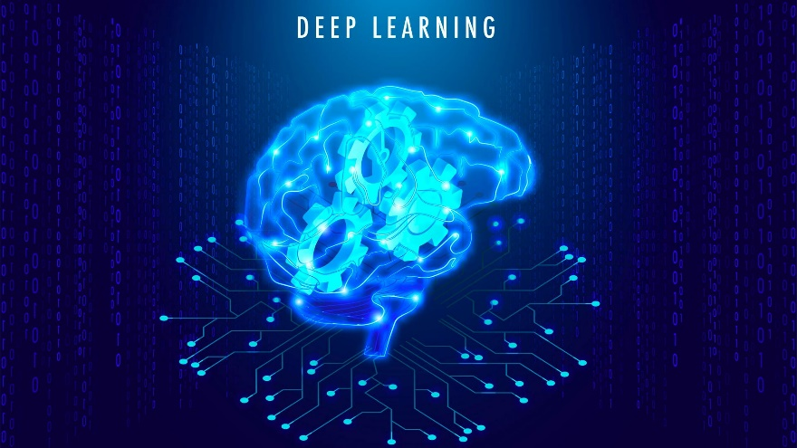

**Importance of deep learning:** The significance of deep learning lies in its ability to automize the process of extracting features from complex data, which brought a revolutionary impact on multiple industries and resulted in great inventories in the field of Artificial Intelligence. Features that made deep learning more approachable than machine learning:

1. *Improved Accuracy –* Deep learning can achieve improved or advanced accuracy in a wide range of applications.
2. *Flexibility*  – Deep learning models are flexible and can adapt to a wide range of new data which includes structured, unstructured, and time series data.
3. *Scalability*  - These algorithms are highly scalable and can handle large no. of datasets with millions of data points. E.g.: Image video processing
4. *Automation* - Deep learning allows for the automation of feature engineering which may reduce the need for human interaction.
5. *Real-world Applications*: From improving health care outcomes to developing automated / self-driving cars. These models can be potential enough to transform many industries like finance, healthcare, security, transportation, and in aerospace, and the military.

2. Latest Developments and Techniques in Deep learning

**Importance of deep learning:** The significance of deep learning lies in its ability to automize the process of extracting features from complex data, which brought a revolutionary impact on multiple industries and resulted in great inventories in the field of Artificial Intelligence.

Some of the Specific fields that use deep learning in their current industry:

* Computer Vision- Deep learning has transformed image and video recognition in industries such as driving, facial recognition, and surveillance.
* Aerospace and military: To process satellite images, detect objects, and even for surveillance.
* Health care: Medical research to analyze the medical images, predict disease diagnosis, drug tests, etc.,
* Transportation industry: For traffic management, vehicle tracking, autonomous driving, etc.,
* Generating Text: NLP, Speech Recognition, and translation.
* Security: to detect fraud, identify security threats and improve cyber security.

Techniques In Deep Learning:

**Convolution Neural Networks (CNNs):**

CNN is a flexible and advanced neural network model that specializes in analyzing and processing image and non-image data. It consists of multiple layers, including input, output, sampling, and connected layers. The neurons in the convolutional layers are responsible for clustering the neurons in the previous layer.

Four Stages involved in building CNN: Convolution, Max pooling, Flattening, and Hidden layers.

CNN can be used for tasks such as image recognitio, video analysis, and NLP, as well as scenarios such as OCR document analysis and one-dimensional input data analysis.

**Recurrent Neural Networks(RNN):**

Recurrent Neural Networks are designed to analyze sequences of variable input length and have been used extensively for predicting time-based data systems. They can help achieve short-term memory in a network, making them useful for managing stock price changes and other time series data.

RNNs can be classified into two types: LSTMs and Gated RNNs.

LSTMs are useful for predicting data in time sequences and have three gates, while Gated RNNs have two gates and are also effective in time series data prediction. Recently many applications, including image captioning, sentiment analysis, and language translations are widely used by RNN.

**Generative Adversarial Networks (GANs)**:

Generally, they create artificial data utilizing two neural networks, a generator, and a discriminator, and differentiate it from real data.

The Generator produces synthetic data that is like real data, while the Discriminator classifies the data as either real or fake. This creates a competitive relationship between the two networks that improves the effectiveness and speed of the overall network. GANs are commonly used for image and text generation, image enhancement, and new drug discovery processes.

**3. HEALTH INDUSTRY**

Medical Image Classification for disease diagnosis

Medical imaging plays a major role in the diagnosis, prognosis, and treatment planning of various medical conditions. However, understanding the captured medical images requires highly skilled medical professionals, who may not always be readily available for the requirement, leading to limitations in the power of medical image understanding. To get better at these limitations, CNNs have emerged as powerful tools for medical image understanding and be better than human experts in many tasks.

Deep learning techniques, mainly convolutional neural networks (CNNs) have shown positive results in medical image classification for disease diagnosis. CNNs have been widely used in this field due to their ability to automatically learn and extract features from medical images, which helps in an accurate diagnosis of diseases.

In this specific application, deep learning models are trained on large amounts of medical image data to classify the images as either **normal or abnormal**. In recent trends, medical image classification using deep learning has proven to be a highly effective tool for improving disease diagnosis. By utilizing CNNs, it is possible to analyze large amounts of medical image data in just minutes and achieve high accuracy in disease classification which may take a long time for human brains if there is a large amount of data. Deep learning models can be trained to identify specific patterns and features in medical images which may not be visible to the naked eye leading to improved disease diagnosis.

**Literature Review**

Recent studies have shown that deep learning techniques, especially CNNs, have significantly improved the accuracy of medical image classification. Researchers have explored various CNN architectures, such as **VGGNet, ResNet, DenseNet, and InceptionNet**, for medical image classification. However, selecting the best architecture for a specific task is challenging due to the high diversity in architecture. Data preprocessing techniques play a major role in the performance of CNNs as they can lead to required output, and researchers have seen many preprocessing techniques some of them are image normalization and data augmentation, to enhance the performance of deep learning models. *(*by Shen et al)

**Problems Addressed by Medical Image Classification**

Medical image classification using these models has the potential to significantly improve the accuracy and efficiency of disease diagnosis. By automating the process of image analysis, these models can be helpful to reduce the time and effort required for manual diagnosis by doctors. This may lead to faster diagnosis as it can give accurate results and treatment which can improve patient results positively and reduce healthcare costs.

Moreover, deep learning models can identify patterns and features in medical images that may not be visible to the human naked eye. For example, a recent study showed that a deep learning model could accurately detect accurate signs of lung cancer in chest X-rays that were missed by radiologists*.* By using the maximum advantage of the power of AI, medical professionals can benefit and can rely on diagnostic tools as it gives accurate results.

Additionally, by analyzing large amounts of medical image data, deep learning models can help identify potential risk factors and enable early detection of diseases. For instance, a deep learning model trained on retinal images can identify early signs of diabetic retinopathy, which can enable earlier invention and prevent blindness. This can lead to earlier diagnosis and more effective treatment, and better patient outcomes.

CASE STUDY:

The researchers in this case study used a CNN algorithm to classify chest X-ray images as either normal or showing signs of pneumonia. The algorithm was trained on a large dataset of X-ray images, with the goal of accurately detecting pneumonia to aid in diagnosis and treatment considering all aspects.

The CNN algorithm works by analyzing the image at different levels in detail, allowing it to detect precise patterns and features that may indicate the presence of pneumonia. After being trained on the dataset, the algorithm was able to accurately classify X-ray images with a high degree of accuracy. The below image shows how CNN works in this case study.

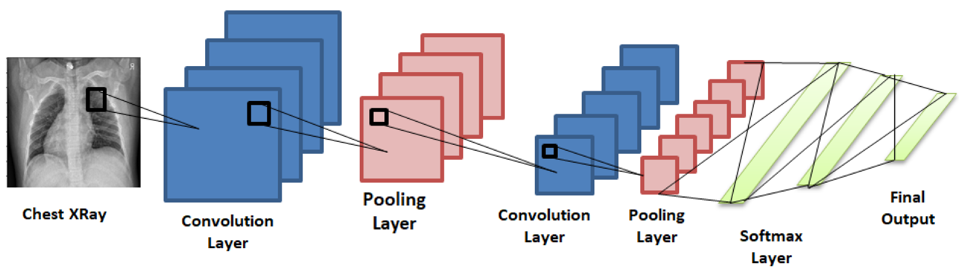

The study was conducted using a dataset of 112,120 frontal-view chest X-ray images from 30,805 unique patients. The dataset was split into three parts training, validation, and testing. The researchers used transfer learning, a technique in which a pre-trained CNN model is fine-tuned on a specific task, to train the CheXNet model on the dataset. (*Rajpurkar* et al. (2017).

The model was trained to classify each X-ray as either normal or abnormal, with the abnormal class further subdivided into 14 categories including pneumonia. The CheXNet model achieved an area under the receiver operating characteristic curve (AUC) of 0.92 for detecting pneumonia, which was higher than the performance of four radiologists who were asked to diagnose pneumonia on the same dataset.

The CheXNet model was also able to localize the areas of the X-ray image that contributed to its classification, allowing for improved interpretability. The study demonstrated that deep learning can achieve high accuracy in pneumonia diagnosis from chest X-rays, which could potentially assist radiologists in clinical practice.

This approach has shown assurance in improving the accuracy and speed of pneumonia diagnosis, potentially leading to better patient outcomes. The use of deep learning methods like CNNs in medical image analysis is an exciting area of research with many potential applications as this is crucial these days when the human brain is limited to some extent. But these algorithms cannot give domain knowledge.

Now, let’s discuss some challenges and solutions of deep learning in the health industry.

Challenges and solutions:

* Transfer learning and fine-tuning techniques have also been used to enhance the efficiency of deep learning models in case of a short supply of availability of data. Researchers have also explored the use of small-sized kernels to capture low-level textual information and multiple pathway architectures to enhance performance. However, these techniques increase the computational complexity of the processor and memory.
* One of the main challenges in medical image classification is the **class imbalance problem**, where the positive class is under-represented, and most of the images belong to the normal class. Researchers have addressed this problem by applying augmentation of the under-represented data.
* Denser CNNs could lead to the vanishing gradient problem, which could be overcome by using skip connections as in the inceptionNet architecture.
* Finally, interpreting CNNs is challenging due to the many layers, millions of parameters, and complex, nonlinear data structures. Researchers have proposed heat maps, class activation maps (CAM), grad CAM, and grad CAM++ for the visualization of CNN outputs. However, the area of visualization is still a challenge.

Limitations:

**Limited training data**: In deep learning medical image classification is the availability of labeled training data. Accuracy is limited as data is limited and also generalizability of deep learning models which also can lead to overfitting.

**Interpretability**: Deep learning models can be difficult to interpret sometimes, making it a challenging thing to understand how they come to their conclusions. This can be a concern in medical applications, where the reasoning behind a diagnosis is important as it is the main thing for medical applications.

**Hardware requirements:** Usage of these models can be expensive and require specialized hardware, such as GPUs, to train and run. This can be a barrier for small healthcare industries.

**Bias**: Deep learning models can learn and maintain biases present in the training data, which can lead to unfair or inaccurate predictions. This can be a concern in medical applications where the consequences of biased predictions can be significant.

Conclusion:

In conclusion, deep learning is an advanced subset of machine learning that has improved the way we approach complex problem-solving methods, especially in the field of medical image classification. It utilizes neural networks that learn and improve as time passes which enabled machines to perform tasks like image recognition with abnormal accuracy. This has led to its widespread adoption in various industries, including healthcare, finance, and automotive. The use of deep learning in medical image classification has shown significant potential to improve disease diagnosis accuracy and efficiency which may be done precisely with the human brain, but it also faces some challenges, such as the class imbalance problem and the interpretability of CNNs. Domain knowledge should also be added as an accuracy measure, recent they even started implementing this feature. Overall, the use of deep learning in medical image classification shows great promise for advancing the field of medical imaging with some limitations.

**Relevant Studies and Experts:**

Recent studies in the field of medical image classification using deep learning include:

"A Survey of deep learning in medical image analysis" by Litjens et al.,

"Deep Learning for medical image analysis: A Review" by Shen et al.,

"Deep Learning Applications in medical image analysis" by Wang et al. Experts in the field include Dr. Bradley J. Erickson from the Mayo Clinic, Dr. Marc D. Kohli from the University of California, San Francisco, and Dr. Matthew Lungren from Stanford University School of Medicine.

Gulshan, V., Peng, L., Coram, M., Stumpe, M. C., Wu, D., Narayanaswamy, A., ... & Webster, D. R. (2016). Development and validation of a deep learning algorithm for the detection of diabetic retinopathy in retinal fundus photographs. Jama, 316(22), 2402-2410.

Liu Xiaoqing, Gao Kunlun, Liu Bo, Pan Chengwei, Liang Kongming, Yan Lifeng, Ma Jiechao, He Fujin, Zhang Shu, Pan

Siyuan et al. Advances in Deep Learning-Based Medical Image Analysis. Health Data Sci. 2021:2021;

Wang, X., Peng, Y., Lu, L., Lu, Z., Bagheri, M., & Summers, R. M. (2018). ChestX-ray8: Hospital-scale chest X-ray database and benchmarks on weakly-supervised classification and localization of common thorax diseases. In Proceedings of the IEEE conference on computer vision and pattern recognition (pp. 2097-2106).

Yadav, S.S., Jadhav, S.M. Deep convolutional neural network based medical image classification for disease diagnosis. *J Big Data* **6**, 113 (2019). https://doi.org/10.1186/s40537-019-0276-2

"Deep Learning for Pneumonia Detection in Chest X-Rays: A Retrospective Study" by Rajpurkar et al. (2017).

Chollet F (2017) Xception: deep learning with depthwise separable convolutions. In: Proceedings of the IEEE conference on computer vision and pattern recognition, (CVPR), pp 1800–1807

References:

<https://journalofbigdata.springeropen.com/articles/10.1186/s40537-019-0276-2>

<https://www.techtarget.com/searchenterpriseai/definition/deep-learning-deep-neural-network>

<https://www.mathworks.com/discovery/deep-learning.html>

<https://www.ncbi.nlm.nih.gov/pmc/articles/PMC7778711/>

<https://jmai.amegroups.com/article/view/4659/pdf>

<https://journalofbigdata.springeropen.com/articles/10.1186/s40537-019-0276-2>